**ASBAT EXAMINATION BOARD**

** EKIGEZO EKIKOMEKKEREZA OLUSOMA OLW’OKUSATU 2023**

**EKIBIINA EKY’OKUBIRI**

**LUGANDA**

Erinnya:___________________________________________________________

Essomero:_________________________________________________________

Ekibiina__________________________________________________________

1. **Jjuzaamu ennukuta ezibulamu**

a ________ ___________ o __________

1. **Gatta ennyingo okole ekigambo.**

ti ____________________

mbe ____________________

**Ka** wuka ___________________

sooli ____________________

lima _____________________

1. **Wandiika emiwendo mu luganda.**

I ________________ 6 __________________

I0 __________________4 ________________

8 __________________ 2 __________________

**(bbiri, munaana, emu, nnya, kkumi, mukaaga)**

1. 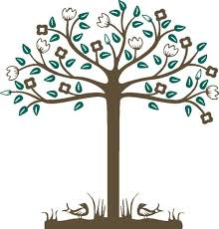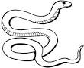**Bituume amannya**

_________________ ___________________

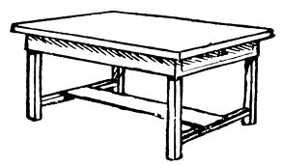

_________________ __________________

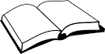 _____________________

1. **Yunga ebigambo okole emboozi.**

|  |  |  |
| --- | --- | --- |
| Maama  Waiswa  Nansubuga  Taata  Omwana | afumba  asamba  asoma  atema  akabira | emmere  omupiira  ebitabo  omuti  amata |

1. ___________________________________________________________
2. ___________________________________________________________
3. ___________________________________________________________
4. ___________________________________________________________
5. ___________________________________________________________
6. **Kola akakuubo**

Red nzirugavu

Black kiragala

White myufu

Green njeru

1. **Wandiika ennukuta entono.**

A _______ E ________ B _________ H _________

D _______ N _________ R ________

1. **Kola ebigambo.**

e – nte ______________________________

O – mu – sa – wo _____________________________

o – mu – so – me - sa ________________________________

O – mu - fu – mbi ___________________________________

O – mu – sirikale ______________________________________

O – mu – li – mi ______________________________________

1. **Yunga ku bigambo ebifanagana**

BITABO baana

KUBA akambe

BAANA ekikopo

EKIKOPO omukazi

OMUKAZI bitabo

AKAMBE kuba

1. **Soma okube ekifaananyi.**

**omuti**

**amazzi**

**omupiira**

**entebe**

**Bikomye wano**